INPUT PROMPT : .
Analyze the uploaded cybersecurity awareness poster and create content that can be shared with students.

SOURCE: .
(Uploaded image containing cybersecurity awareness information such as strong passwords, MFA, phishing prevention, software updates, and safe internet practices.)

Source link: https://drive.google.com/file/d/1Xu-8UhnW_-T0IEc7jt9fN66oS_qVQq1g/view?usp=sharing
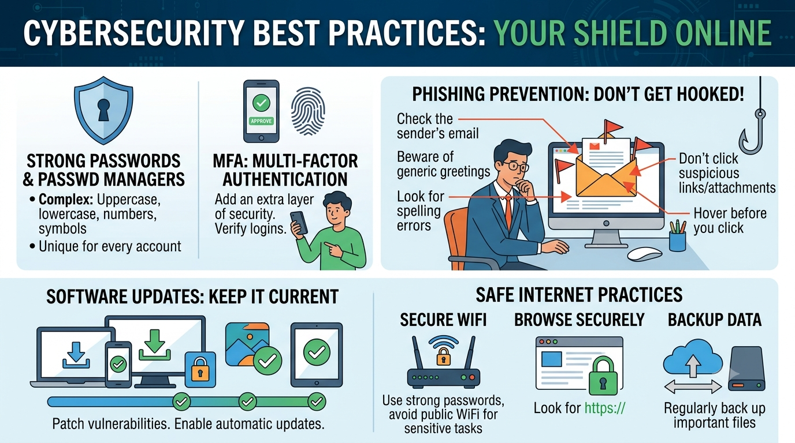

PARAMETERS: .
Parameter: LinkedIn Post, Presentation
Tone: Educational, Student-friendly
Language : Hindi and English and a template is provided
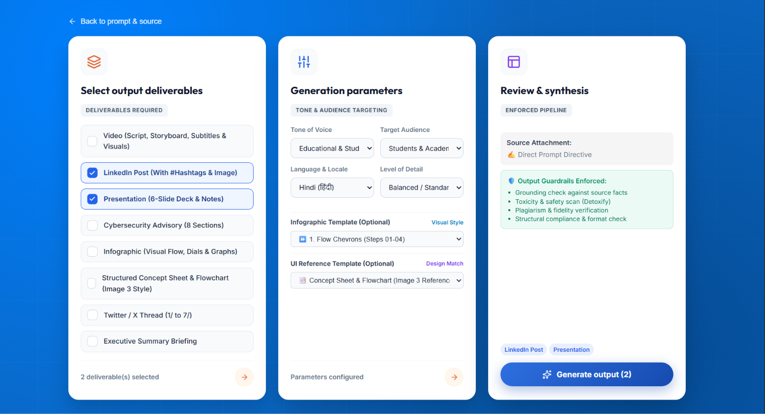

OUTPUT GENERATED: .
(In hindi for linked in)
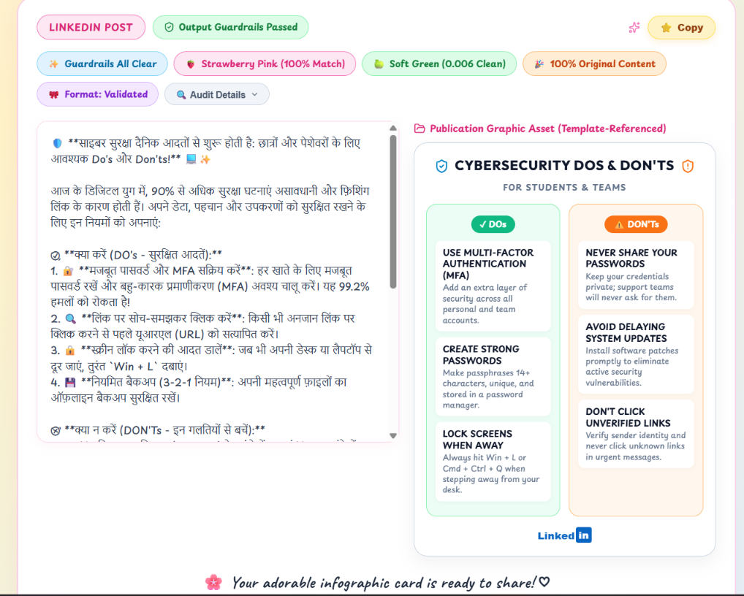

(powerpoint)
